**I. Product Information**

|  |  |
| --- | --- |
| Packaging Material Name | Café Gusto 3-in-1 Corrugated Carton |
| Item Code | CTN-3in1 |

**II. Printing Details**

|  |  |
| --- | --- |
| Company Address | Manufactured By:  TMT FOODS INC.  Lot 29 Blk 27, Green Valley  San Nicolas III, Bacoor, Cavite  PRODUCT OF THE PHILIPPINES |
| Barcode |  |
| White Creamy Coffee Mix | 4806538450135 |
| Brown Complete Coffee Mix | 4806538450128 |
| Clasico Complete Coffee Mix | 4806538450111 |

**III. Specifications**

1. **Dimensions**

|  |  |  |
| --- | --- | --- |
| Length | Outside Diameter | 390 +/-2mm |
| Inner Diameter | 386 +/-2mm |
| Width | Outside Diameter | 280 +/-2mm |
| Inner Diameter | 276 +/-2mm |
| Height | Outside Diameter | 183 +/-2mm |
| Inner Diameter | 179 +/-2mm |
| Joint Tab Size | | 35 +/-5mm |
| Flap Size | | 142 +/-2mm |
| Total Width | | 467 +/-2mm |
| Total Length | | 1372 +/-2mm |
| Flute/Pound Test or Board Type* | | C/32# |
| Color / Shade* | | As per Color Guide |
| Printing / Design* | | As per Factory Card |
| Test Requirements: | | NONE +/-10% |

1. **Visual Inspection**

|  |  |
| --- | --- |
| Board Bonding | No delamination |
| Glued Joint Bonding | Adequate |
| Barcode | Readable & Correct |
| Slotting* | +/3mm |
| Joint Gapping* | 2 ~ 10 tolerance |
| Flap Gapping | 4 mm tolerance |

***Continuation…***

|  |  |
| --- | --- |
| Scoring | No Cracking |
| Squaring | No off square |
| Printing Distance/Location/Centering | As per Factory Card |
| Gluing Condition | No sticking inside/outside |
| Trimming/ Cutting Condition | No hanging trimmings |
| Slotting Condition | No rugged / No mis-lot |
| Printing Condition | No smearing/blurred pint |
| Bundling / Packing | As per specs |

 *\*Based on COA provided by the supplier during delivery.*

**IV. Sampling Size and Acceptable Quality Limit (AQL)**

|  |  |
| --- | --- |
| **Sampling Size** | For Normal Sampling Plan, use Military Standard 105E, general inspection to check for aesthetic and functional properties and dimension of the box. |
| **Acceptable Quality Limit (AQL)** | |
| **1.00 %** | *Critical defects:* Deficiencies characterized as physical or functional elements that eventual utilization will result to the contamination of the content, mis-identification of the product or content and total operating failure.   * Wrong dimension * Below standard Edge Crust Test |
| **4.00 %** | *Major defects:* Deficiencies other than critical, that likely to affect the functional properties of the laminates, make the product difficult to use and reduce the production yield.   * Wrong print of barcode * Different color * Glued weakly * Damaged/Torn portions * Unreadable print * Incorrect artwork * Off odor * Foreign materials |
| **6.50 %** | *Minor defects:* Deficiencies that do not affect the functional property of the corrugated carton.   * Ink smearing * Misprint * Unclear printing of text/art * White spot * Fibrous edges and poor trimmings * Deformation/Dents |

**V. Storage Condition**

Corrugated carton should be stored in clean and dry area at ambient temperature (27-400C), away from strong odors, heat, and direct sun light.

**VI. Illustrations**

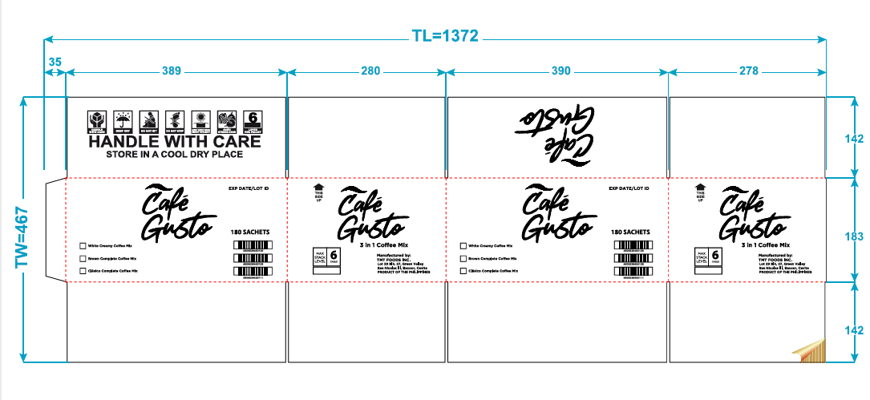

Café Gusto – 3in1 Corrugated Carton Mechanical Drawing

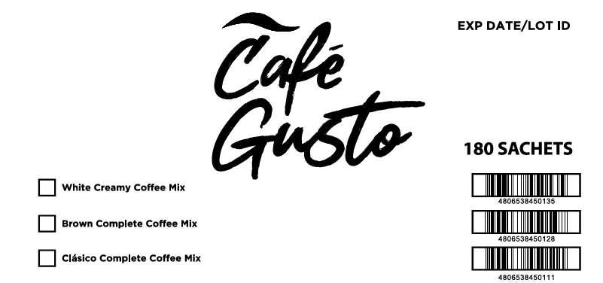

Café Gusto – 3in1 Corrugated Carton Front and Back Panel



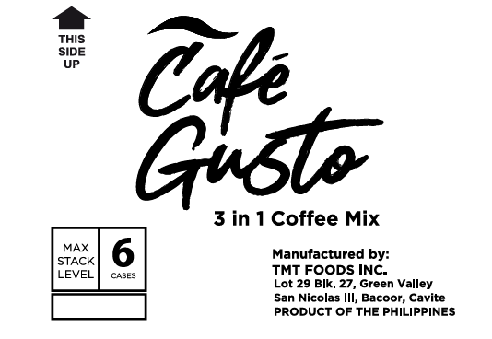

Café Gusto – 3in1 Corrugated Carton Side Panel



Café Gusto – 3in1 Corrugated Carton Top Panel

**Revision Record**

|  |  |  |  |
| --- | --- | --- | --- |
| Revision no. | Date | Revision | Author |
| 00 | January 29, 2024 | Initial Issue | C. Quintans |